Q1. Create a sample table in postgres/mysql with following columns (15 Marks)

Table Name : cdac_power_bi

Column

Name - varchar

Id- integer

Age- integer

Dob – date

Connecting Postgres to Power BI

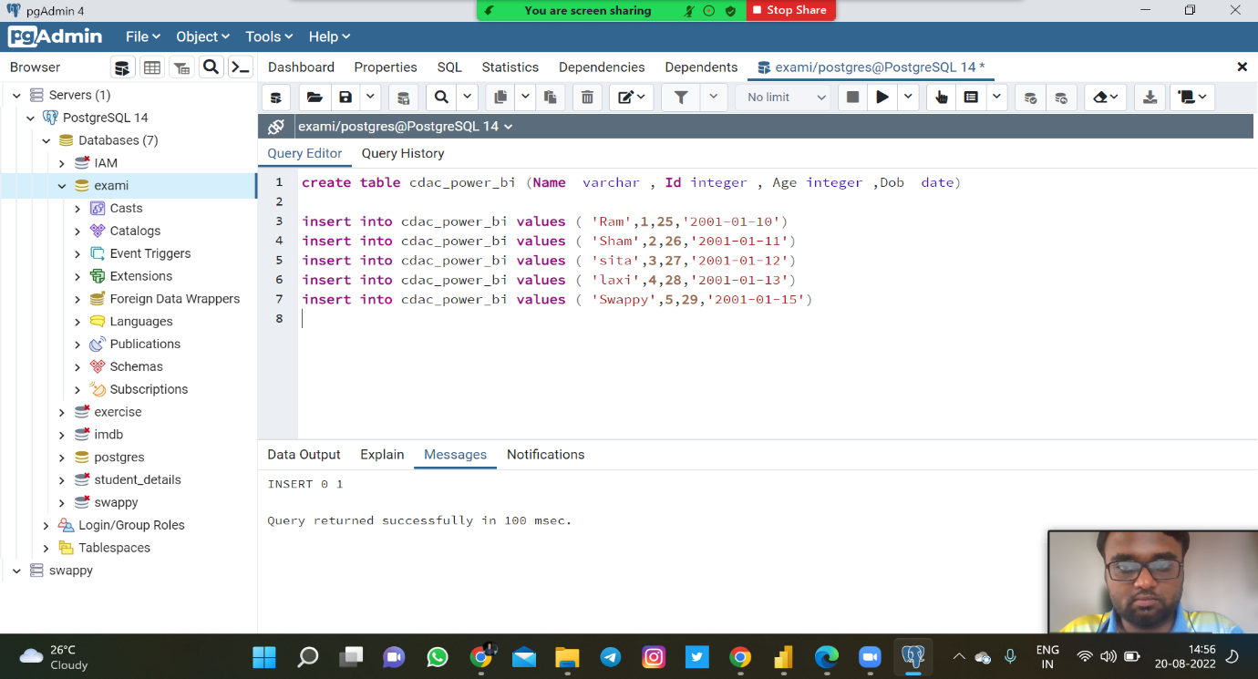

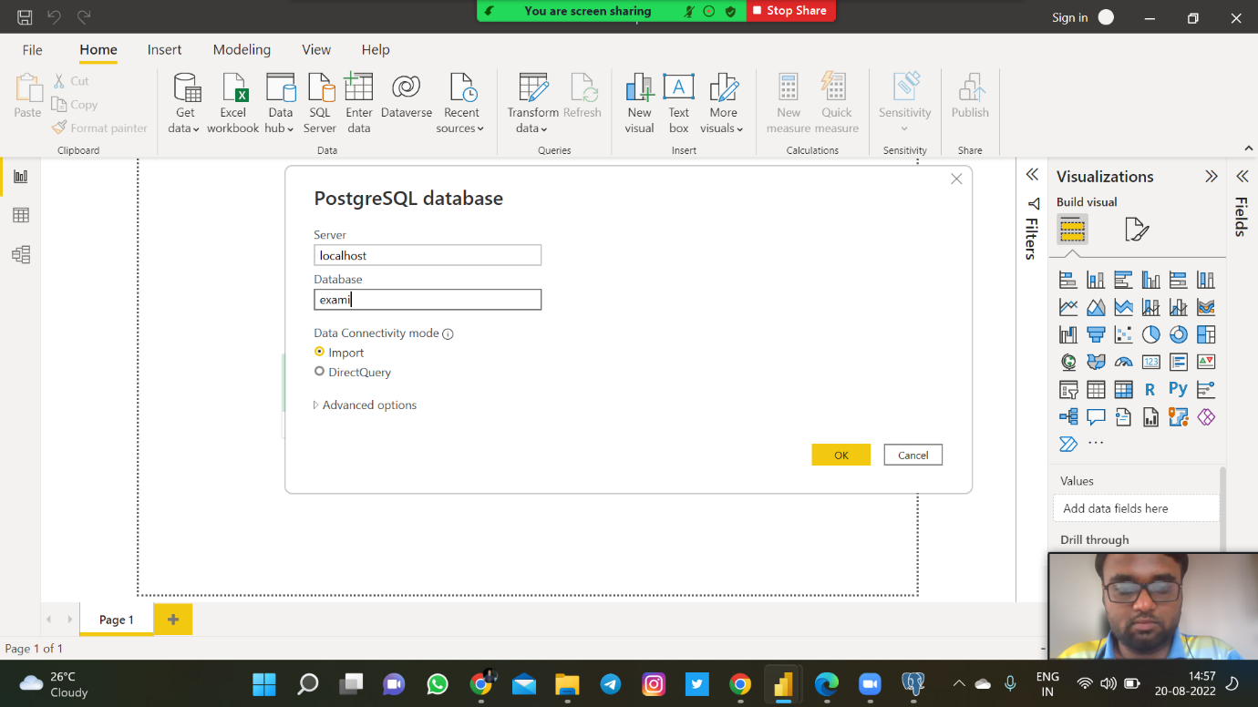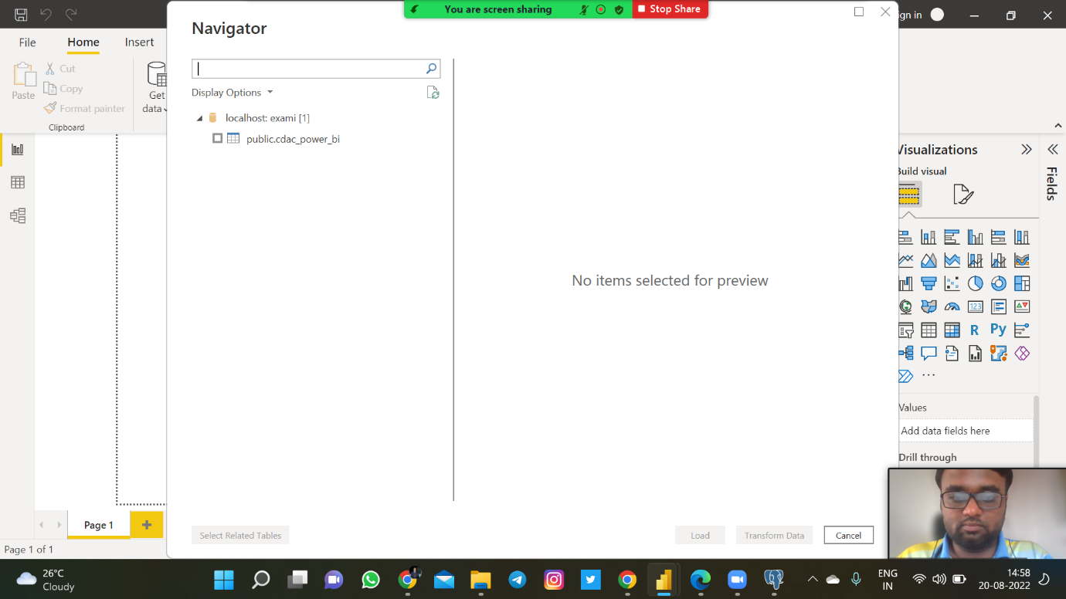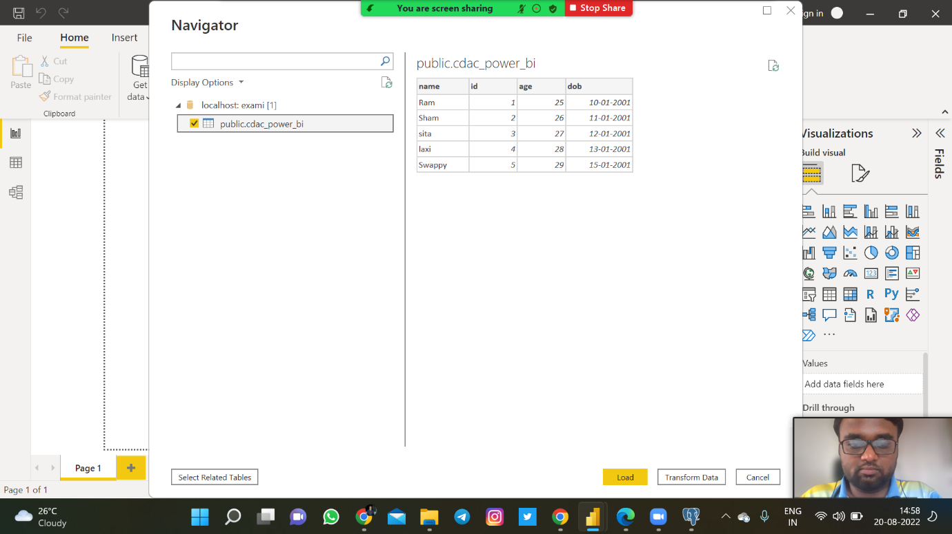

Insert 5 dummy rows into it and then connect to superset and populate

1. Table Chart
2. Card chart showing max age

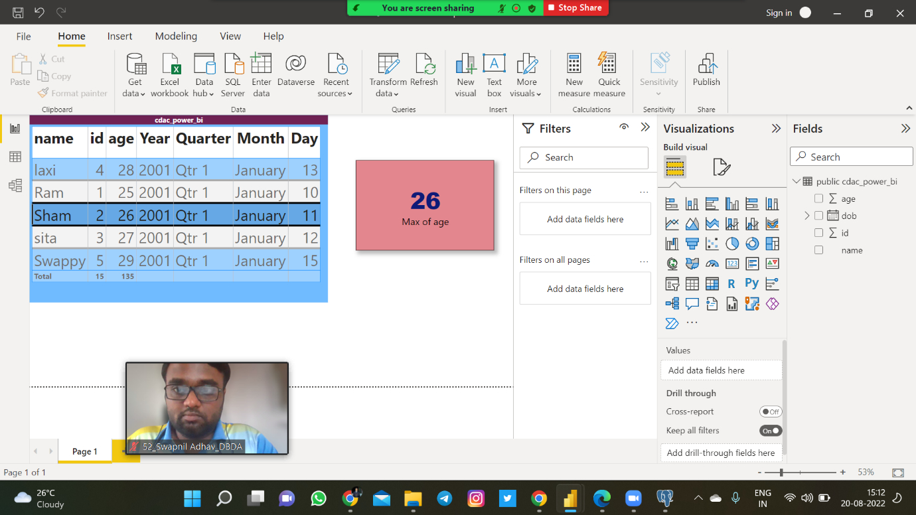

Q2.On product_table data set do the following (25 Marks)

All Charts

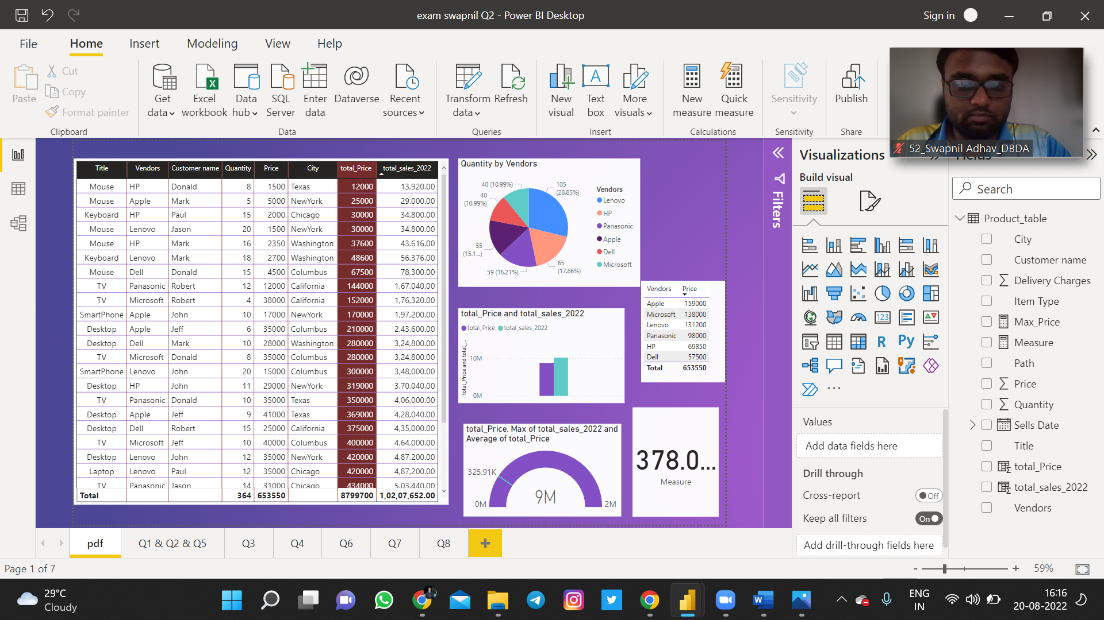

Answers of below questions..

1. Create table chart with title , vendor,customer name,quantity,price,city

2. Add new calculated column naming total_sales which is derived from quantity * price

5.Create one more column naming total_sales_2022 which is derived from quantity *

price * 1.16

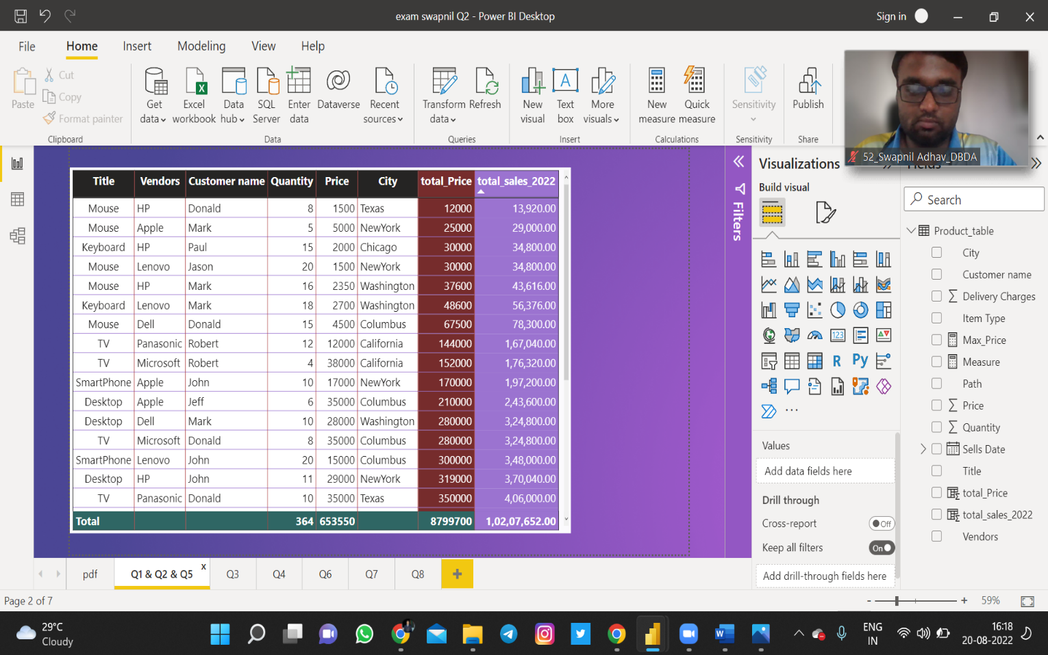

1. Add new measure naming max_price to get max of price column and then display everyvendor max price in table chart.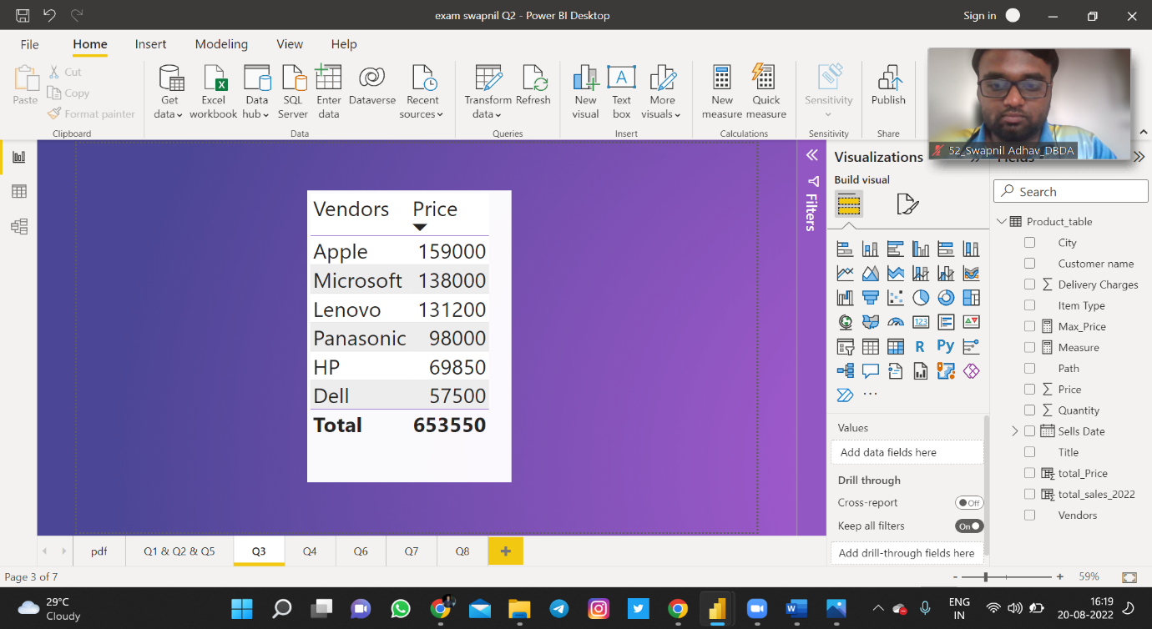
2. Create pie chart showing the value and percentage of quantity by vendors

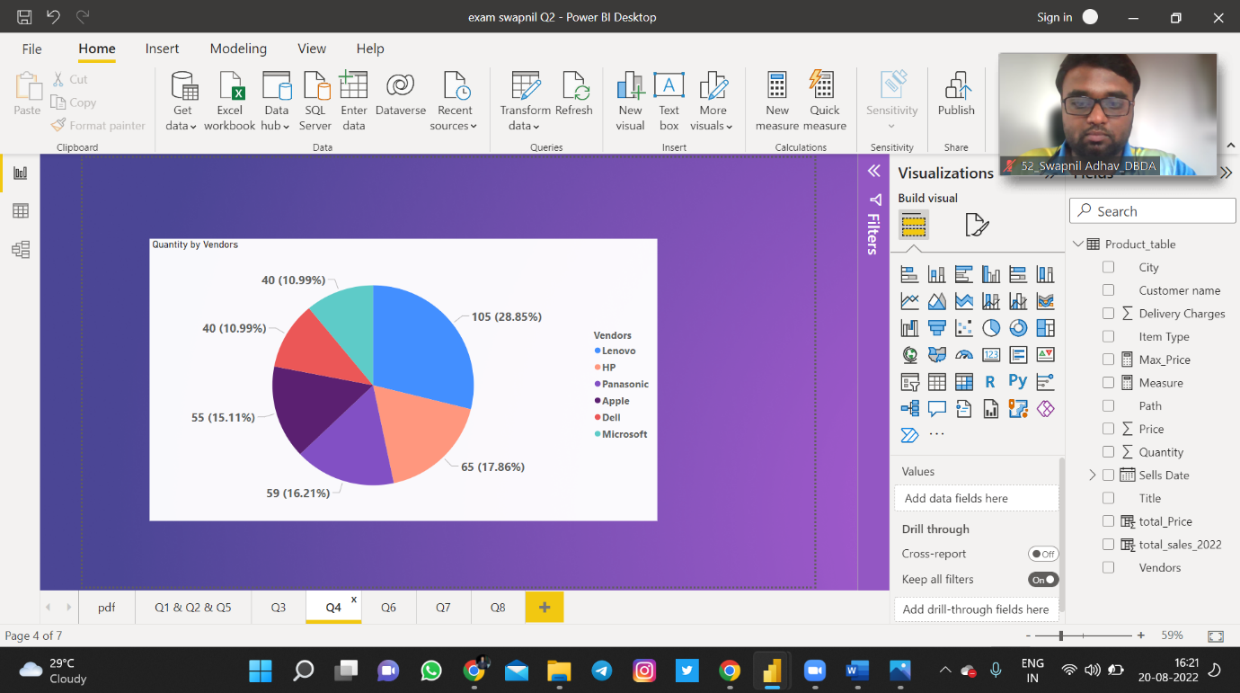

6.Create clustered column chart showing both total_sales and total_sales_2022

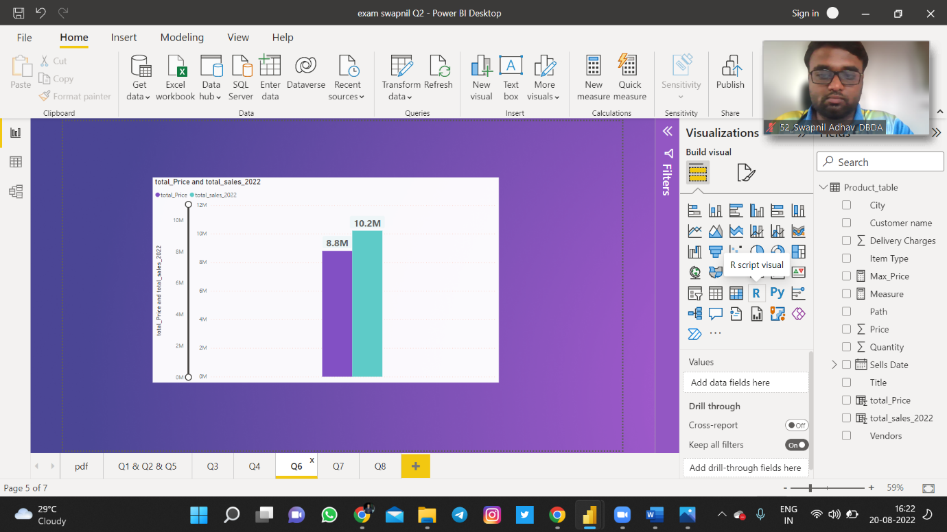

7.Create a slicer chart of price

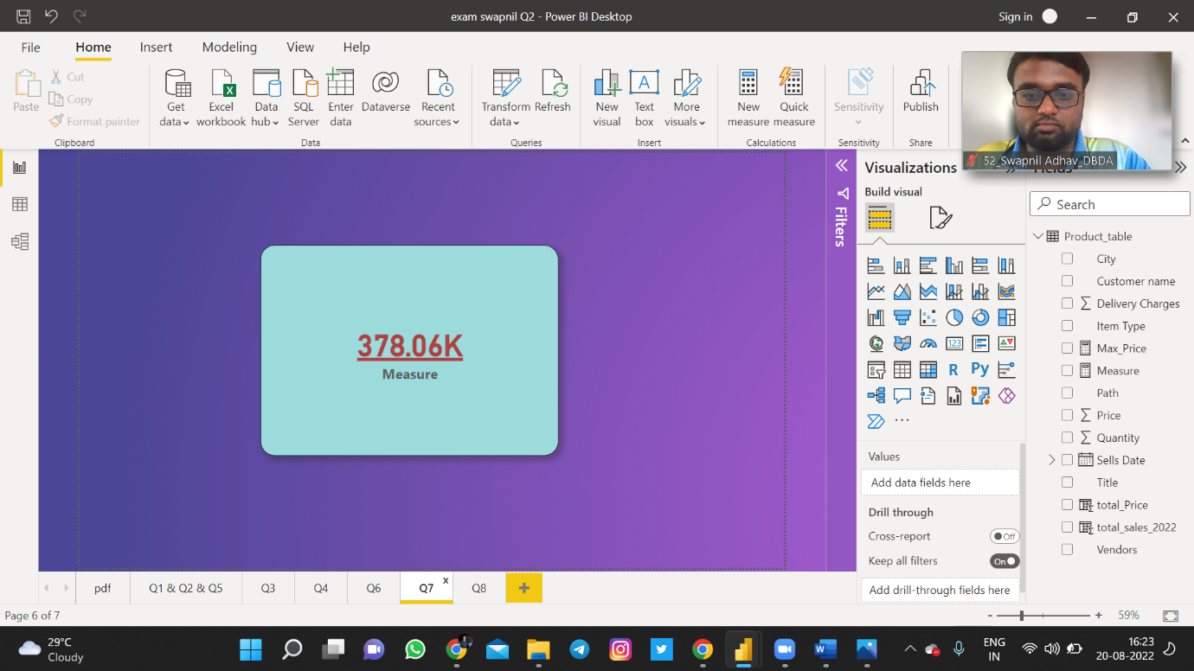

8.Calculate avg sales and show in tile

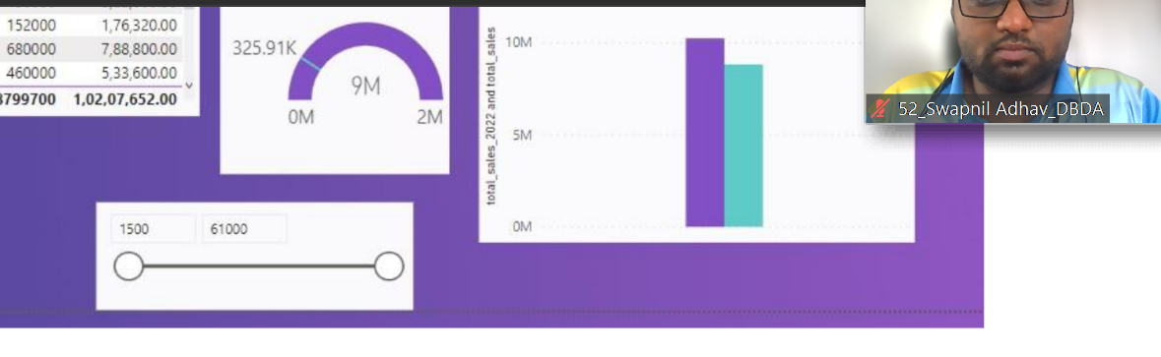

9. Create gauge chart with

○ value as total_sales

○ Maximum value as max of total_sales_2022

○ Target Value as average of total_sales

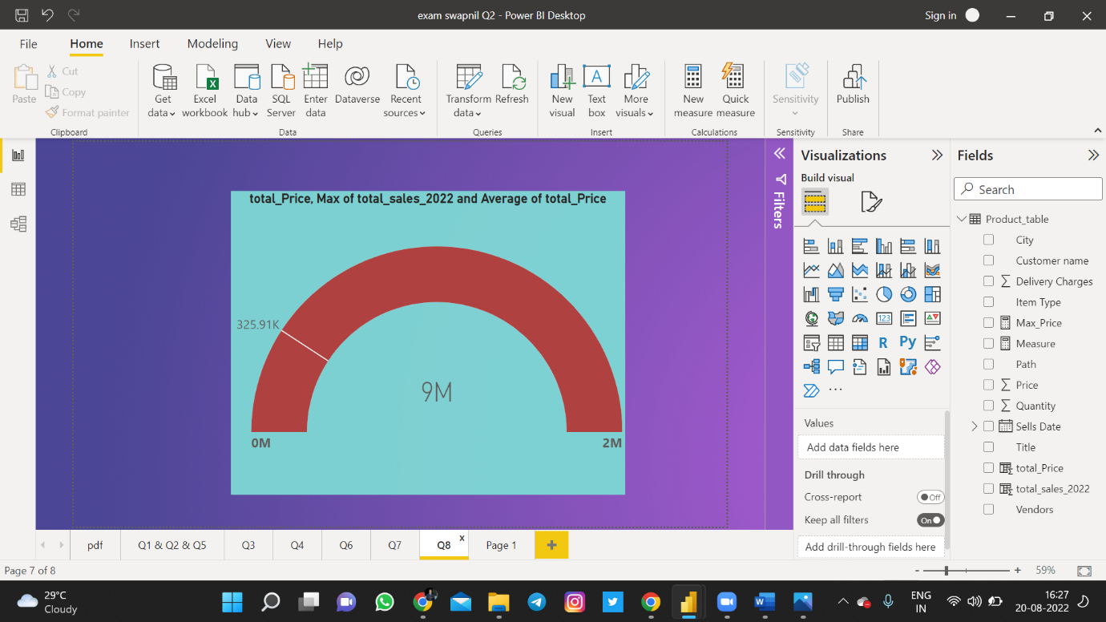ss